**How to Delete Instagram account step by step guide.**

Having a decision of deleting instagram account may have many reasons, like your addiction towards using Instagram and etc. You have an option of deleying instagram and disable instagram in which if your wishing to comeback on instgram so better to disable instagtam account. Because Deleting Instagram account deletete your profile, Followers any others data permanently which you cant get back .

Disable account have an option of reactivate again your same account without loosing your followers and any other data.

Here we come up with the topic of both that’s how to delete instagram account and how to disable instagram account, and how to reactivate after disable.

**How to delete instagram account**

Deleting your instagram account will vanished all of your followers, photo, video, comment and likes. If you really don’t want to use your instagram account again so go with delete instagram account, because it doesn’t keep your any data store.

After del your instagram you cant sign up with the same username or also cant use that same username for your new instagram account.

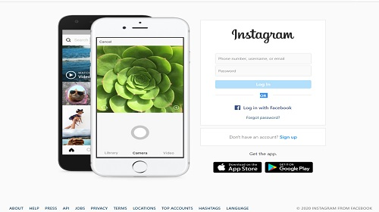

Navigate to Instagram.com from your mobile browser or Desktop (You cant Del instagram account using your mobile application)

Sign in to your Instagram account.

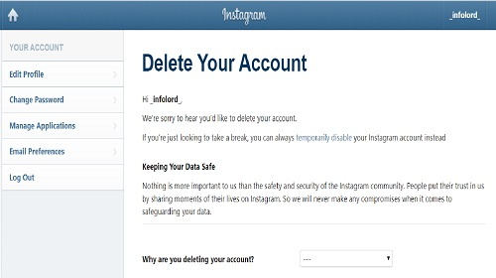

Go to instagram delete your accout page.

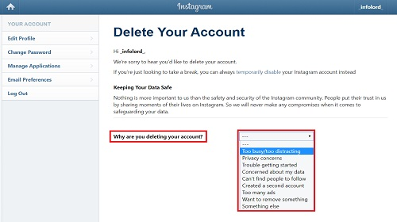

Give the reasons for del you account by selecting an appreciate option from the drop down menu as show in Image

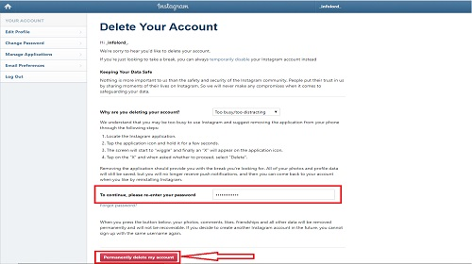

Enter your password to continue for deleting you instagram account and click on Permanently Delete my account

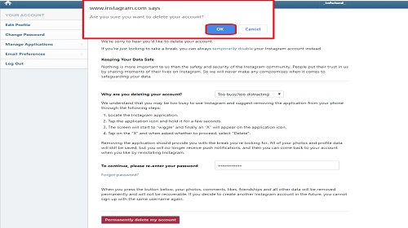

After that you will recive a notification from instagram for surety of deleting instagram just click on OK.

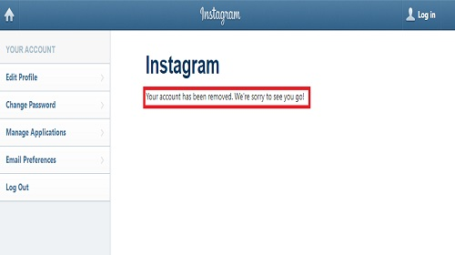

After successfully delting your account you will see message from Instagram ( Your account has been removed. We re sorry to see you go!

**How to temporary disable instagram account**

Temporarily disabling your account wont del your profile, photos, comments and likes it will just all get hide from your followers and Instagaram. You can reactivate your Insatgram account anytime by using you username and password.

Once you logged in all Likes, followers, Comments, message and etc will get restore.



Navigate to Instagram.com from your mobile browser or Desktop (You cant disable instagram account using your mobile app)

Logging to your account



Click on your profile icon at right top

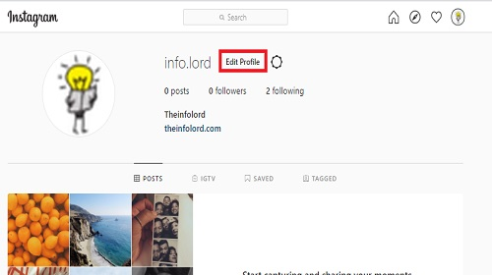

Click on Edit Profile

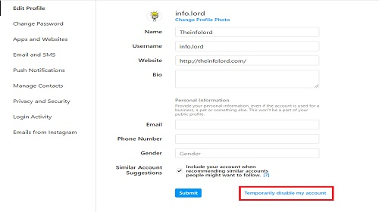

Click on Temporarily disable my account at the bottom right side

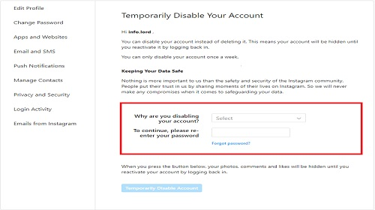

Select the appreciate resone for disableing instagram account and enter you password

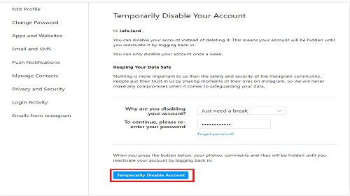

Click on Temporarily disable account to continue

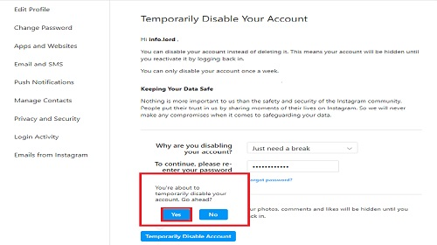

After that you will recive a notice message from Instagram, Click on yes to continue Disable you account.

**How to reactivate instagram account**

Reactivating instagram account is an simplest things to do. But you can only reactivate your account if you have temporarily deactivated your account. Deleting Instagram doesn’t have an option to reactivate.

To reactivate your instagram account just simply login to instagram using your user name and password. Once you login all your profile, post, comment, likes will show agains to your followers.

**Final Words**

Here after taking all above steps you can successfully delete your account or disable your account. We have come with each and every step of Deleting and Disable Instagram account for making your work easy.